Swachha Bharat Pakhawra-2018
16 December – 31 December
ICAR-Central Inland Fisheries Research Institute, Barrackpore, Kolkata

Institute: ICAR-Central Inland Fisheries Research Institute
Day: 31.12.18
Activity: Closing ceremony of Swachh Bharat Pakhawda-2018 at Auditorium of the institute

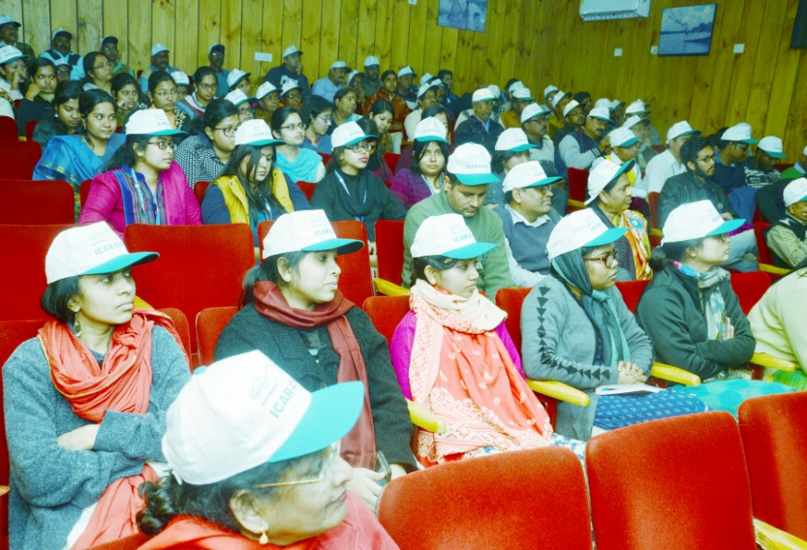
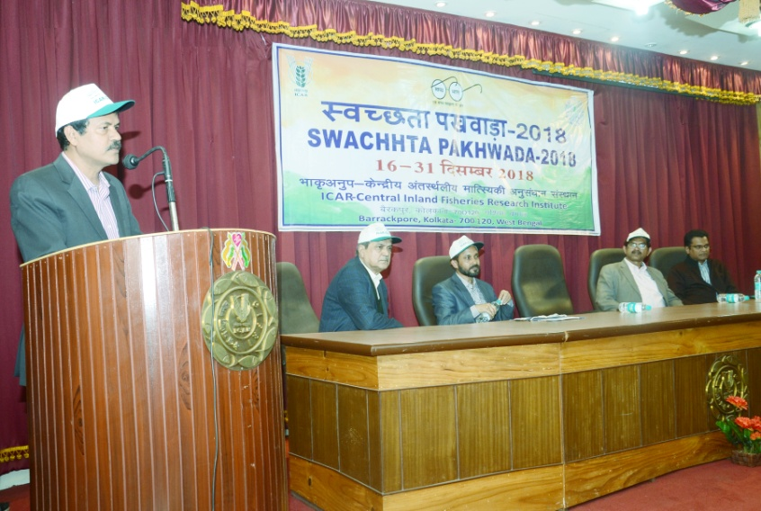
On 31.12.18, ICAR-CIFRI conducted a closing ceremony on the 15 days long Swachh Bharat Pakhawda. The programme was graced by Dr. N. K. Bandyopadhyay, Medical Officer, ICAR-CIFRI who was present as chief guest for the event. Dr. B. K. Das, Director ICAR-CIFRI, Dr. V. R. Suresh, Chairman, Swachh Bharat Committee and Head of the Division, REF Division, ICAR-CIFRI, Dr. B. P. Mohanty, Head of the Division, FREM Division, ICAR-CIFRI and Shri. Rajiv Lal, Chief Administrative Officer, ICAR-CIFRI chaired the programme. All the staff members and research scholars were present in the closing ceremony. Dr. N.K. Bandyopadhyay spoke on potential diseases due to lack of proper sanitation and remedies and preventive measures to avoid them. He emphasized on importance of cleanliness and personal hygiene in day to day life. Dr. B. K. Das, Director, ICAR-CIFRI has delivered an inspiring talk on necessity of observing “Swachh Bharat Abhiyan” and duty of each sensible citizen to contribute to “Clean India”. The director also applauded CIFRI staffs for their sincere and laborious voluntary contribution for cleaning the institute premises and outside. Dr. V. R. Suresh, Chairman, Swachha Bharat Committee presented his remarks on initiatives and responsibility of the institute towards Swachh Bharat Mission. Dr. Sajina A. M., Scientist ICAR-CIFRI presented a brief report of Swachh Bharat Pakhawda-2018 activities carried out at the institute. Lastly, Ms. Sefali Biswas, Member Secretary, Swachha Bharat Committee proposed the formal vote of thanks.
